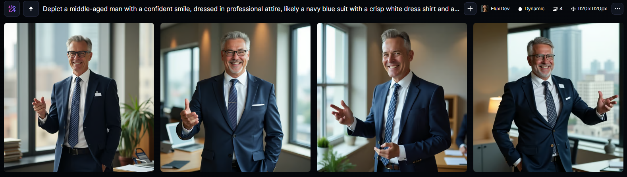

“Depict a middle-aged man with a confident smile, dressed in professional attire, likely a navy blue suit with a crisp white dress shirt and a slim tie, possibly with a pattern of subtle diagonal stripes, standing in a modern office with a cityscape view through the window behind him, against a neutral beige or light gray background, with a few hints of warm wood accents from a nearby desk or bookshelf, as he gestures emphatically with his right hand, holding a presentation clicker, while his left hand rests confidently in his pocket, with a name tag or a badge on his lapel that reads "Advertising and Promotions Manager", and a few props such as a folder, a notebook, or a tablet nearby, to convey his role and profession.”

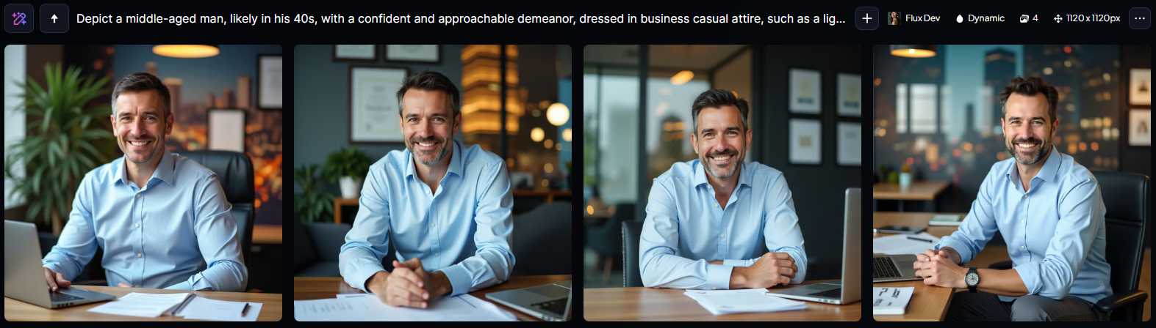

“Depict a middle-aged man, likely in his 40s, with a confident and approachable demeanor, dressed in business casual attire, such as a light blue dress shirt and dark gray trousers, sitting behind a modern, sleek wooden desk with a few papers and a laptop scattered across it, surrounded by vibrant, urban cityscape background, possibly with blurred skyscrapers or abstract city lights, as an Advertising and Promotions Manager, with a gentle smile on his fair-skinned face, defined jawline, and short, dark brown hair, his piercing brown eyes looking directly at the viewer, conveying a sense of professionalism and friendliness, with a few subtle facial lines suggesting years of experience in the industry, and possibly a few framed certificates or awards on the walls behind him.”

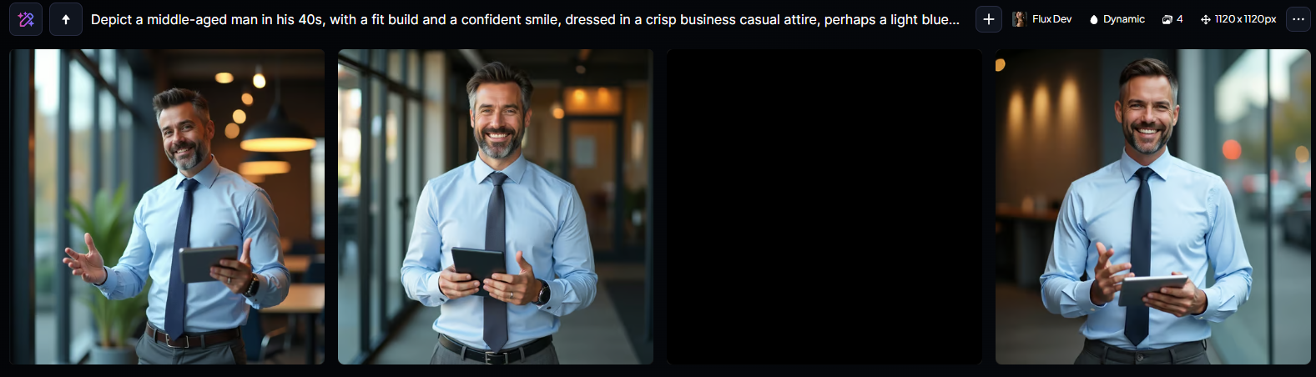

“Depict a middle-aged man in his 40s, with a fit build and a confident smile, dressed in a crisp business casual attire, perhaps a light blue dress shirt with a slim tie and dark grey trousers, standing in front of a sleek, modern cityscape or a trendy advertising agency office, showcasing his professional yet approachable demeanor as an Advertising and Promotions Manager, with a faint hint of creativity in his brown eyes and a slight stubble on his defined jawline, his dark brown hair neatly styled, holding a tablet or a futuristic smartphone in one hand, with the other hand gesturing expressively as if presenting an innovative marketing idea, surrounded by subtle hints of urban chic and modern technology, with a warm, natural color palette and soft, cinematic lighting.”